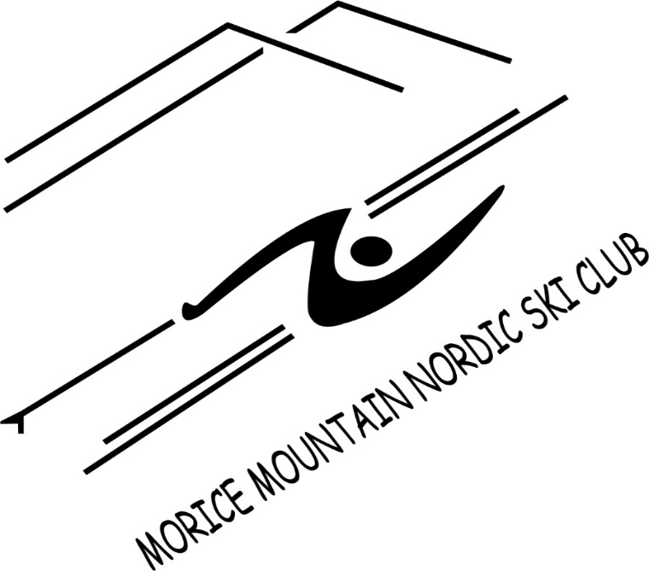
March 2021

Purpose
To create superb cross-country ski and snowshoe opportunities in a unique natural setting.

Mission
Develop and encourage an active, supportive, welcoming outdoor recreation community.

Vision
An enhanced, recognized Morice Mountain Recreation Area celebrating the natural beauty, encouraging community participation and offering healthy outdoor activities all year round.

Values
Volunteerism  Quality experiences  Community building  Healthy, active living  Affordable access to nature year-round | Quiet natural spaces  Responsible attitude to public lands  Respect for natural environment  Respect for other users  Shared resources

